Step 1:  Gather your equipment: Gloves, anti-bacterial spray, toilet brush, toilet cleaner and cloth.  This means you won’t have to keep getting up, or spread germs around your home. | 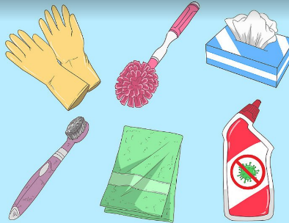
Step 2:

Flush the toilet, and give the toilet seat a wipe down with hot water- pour the rest of the hot water into the bowl to help with cleaning.

Wiping down first will stop the spread of germs whilst you clean the toilet bowl.
Step 3:  Scrub the bowl. Pour toilet cleaner into the bowl then use the toilet brush to scrub the bowl top to bottom.  Make sure you follow the directions on your toilet cleaner. | 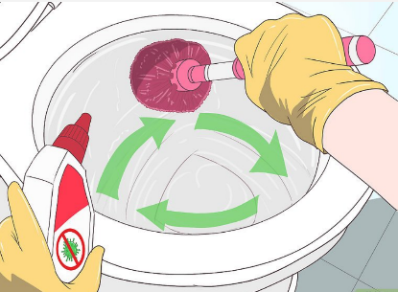
Step 4:  Clean the lids, handle and around the rest of the toilet. Use your anti-bac spray and a cloth and small brush (like an old tooth brush)  This will clean away any other germs or splashes from cleaning the bowl. | 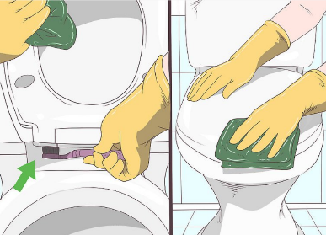
Step 5:  Flush the toilet, then wash your hands thoroughly.  *Try to keep all your toilet cleaning equipment together, so it doesn’t get mixed up with other items. | 