Step 1:

Most people get phone calls from people they don’t know.

You don’t have to answer the phone – but if you do – remember to be careful.
Step 2:  If the caller wants you to give them information you are not happy to give – tell them.  Often nuisance callers want you to agree to give money or buy something you don’t need. | “No Thanks”
Step 3:

Remember to never give out your bank or card details over the phone to someone you don’t know who calls.

Your bank will never call and ask you for your account details/PIN number -as they already know them – the caller could be a scammer.
Step 4:  If you keep getting nuisance phone calls you can try and block the number.  If you know the number as a nuisance caller – don’t answer. | 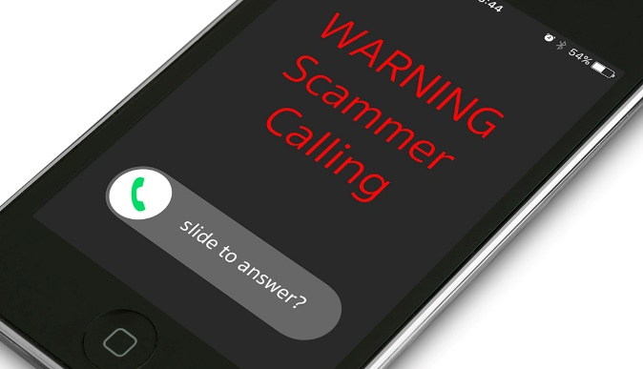
Step 5:

Speak to the Housing Team or another member of Assist Trust staff if you want any more advice or help with nuisance calls.

Title: Dealing with nuisance phone calls

