Step 1:  First, check the hoover bag if it is full it will need to be emptied.  If the bag is full the floor will not be hoovered properly. Check the instructions on your hoover, as all hoovers are different. | 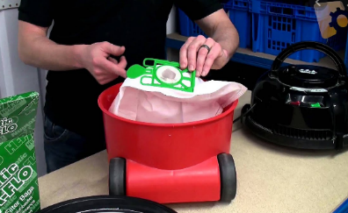
Step 2:

Move small items and clutter off of the floor.

This means you will be able to clean the whole space freely, and nothing will accidentally get sucked up.
Step 3:  Plug your hoover into a near plug socket and then switch hoover on.  You may need to change plug sockets as you hoover round your home, so the cord does not get stretched. | 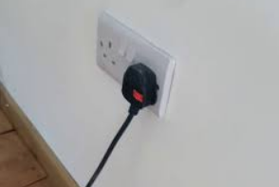
Step 4 :  Push the hoover slowly in a forwards and backwards motion across the floor.  If you find a hard to reach spot, remove brush, and use the smaller nozzle. | 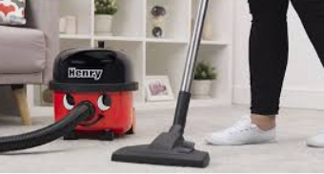
Step 5:  Once finished, pull out plug and wind/ retract the plug and wire.  This will stop it getting tangled, or the plug damaged. | 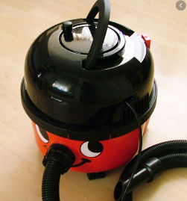

Title: Hoovering

