Step 1:

If you cannot get into your home because you cannot find your keys – stay calm.

Is there anyone you can call who has a spare key?

Can your landlord help you?
Step 2:  If no-one else has a spare key – you can call a locksmith to come and help you.  You can call a local locksmith company – remember you will need to pay them for this.  If you have a neighbour you trust – you could ask them for help to call a locksmith. | 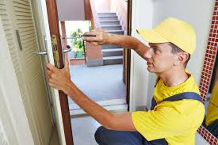
Step 3:  Think how to stop this happening again.  Make sure a family member you trust has a spare key.  Think about fitting a key box near your front door –and putting a spare key in it.  Don’t put spare keys under door mats or under plant pots – this is not safe. | 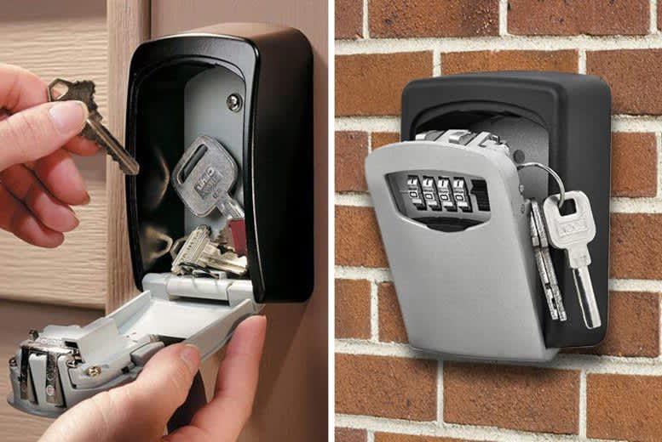
Speak to the Housing Team if you would like some further information.

We can give you advice on keeping your keys safe.

