Step 1:  Before opening the door – use the spyhole, or a window - to see who is there.  If you have a door chain – put this on first.  You don’t have to answer the door if you don’t want to. | 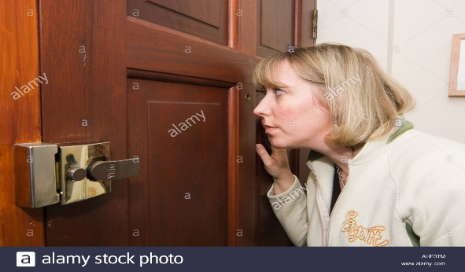  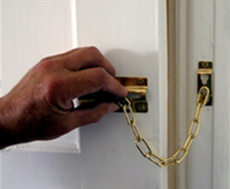
Step 2:  If it’s someone you are expecting – like a repairs person – ask to see their ID before letting them in.  If you are unsure – ask them to wait outside while you call the company they work for - to check who they are. The telephone number will be on the ID card. | 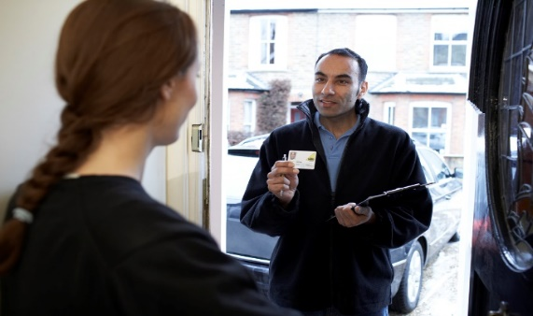  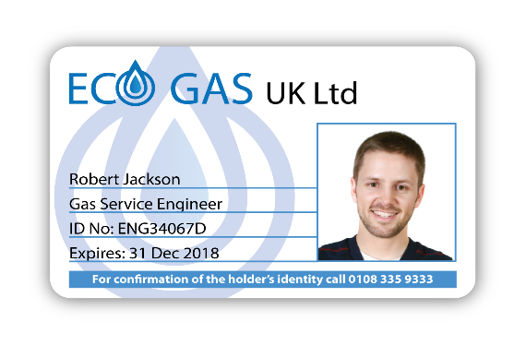
Step 3:  Keep information to yourself – don’t tell people if you live alone, or answer questions about what times you are normally home or at work.  Sales people often like to come in - to have more time to sell you things you probably don’t need. Be polite, but firm – ask them to leave if you are not interested.  Call the Police – 999 – if you are feeling unsafe. | 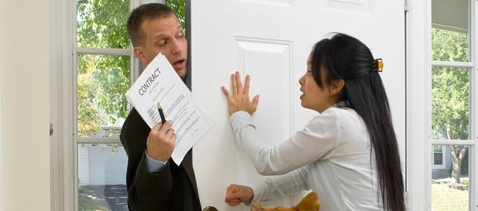  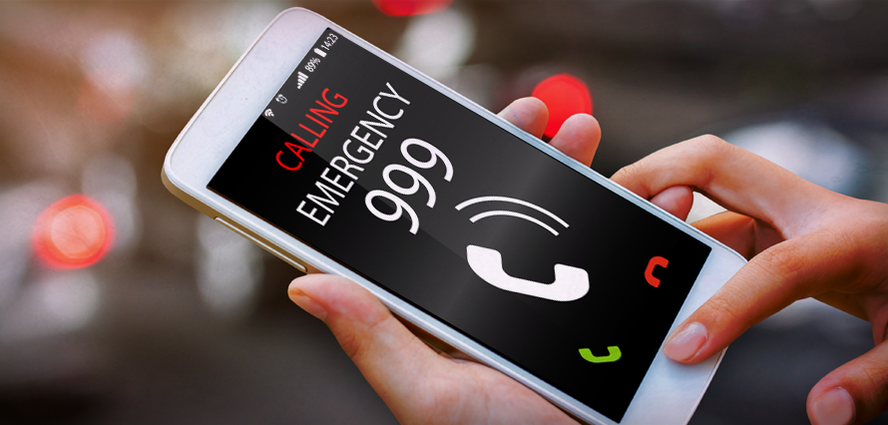
Speak to the Housing Team if you would like some further information.  We can give you some handy stickers for your door - to try and stop unwanted visitors. | 