Step 1: If you lose power at home, you may need to reset the fuse box.  Use a torch to help you if this happens when it is dark outside.  It is always a good idea to know where your fuse box is located. | 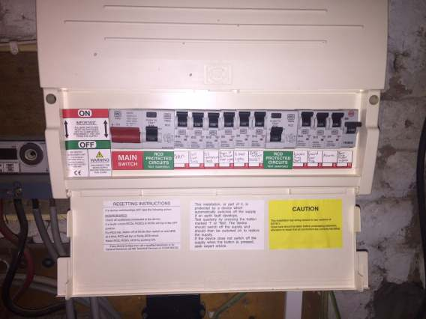
Step 2: If one of the switches is off, you can usually turn it back to on for the power to come back on.  If the problem keeps happening you should get someone else to help you.  Sometimes appliances like your kettle or toaster could be faulty – causing the power to keep going off. | 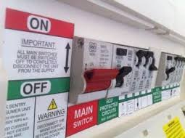
Step 3: If steps 1 and 2 do not help, the problem may be affecting the whole neighbourhood.  See if your neighbours’ homes have any lights on. | 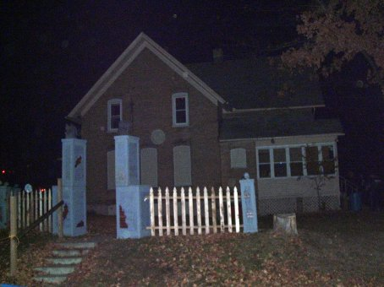
Step 4: If the power is off in the neighbourhood you will have to wait for UK Power Network to fix the problem.  You can find out what they are doing to help by checking their website, or calling them on your phone. | www.ukpowernetworks.co.uk

