Step 1:

Clear area before mopping, and open a
window.

This will make it easier to move around and dry the wet area quicker.
Step 2:  Fill bucket half way with hot water,  then add floor cleaner.  Make sure you check the instructions on your floor cleaner. | 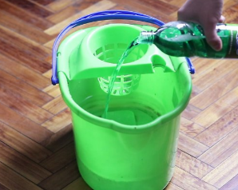
Step 3:  Soak mop in water.  Make sure you move the mop in the water each time, to remove dirt. | 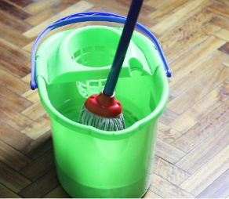
Step 4:  Strain mop of excess water.  Do this each time so the floor doesn’t get too wet. | 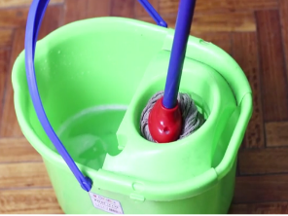
Step 5:  Start in the furthest corner of the room  Working back means you will not tread on the clean floor. | 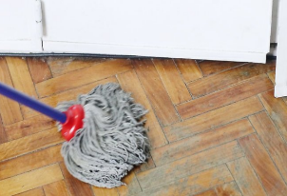
Step 6:  Move the mop in figure of 8 or circles.  This helps pick up all the dirt. | 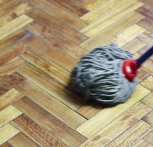
Step 7:  Drain the dirty water outside, down a drain or on the grass.  Putting chemicals down the sink is bad for the environment. | 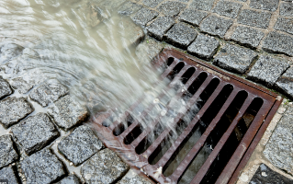

Task: Mopping the floor

