Step 1:  To make cleaning the microwave easier you can put a mug or bowl of water in for a few minutes on full heat  This will make it easier to clean as it loosens any dirt. | 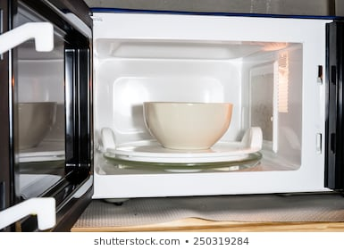
Step 2:  Get a bowl of warm soapy water (or cleaning spray & cloth or cleaning wipes)  Make sure you follow the instructions on the cleaning product for how much to use. | 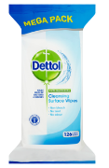  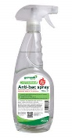  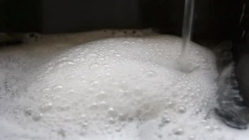
Step 3:  Carefully take out the mug/bowl and then remove the glass turntable and it’s base  This is to make sure you clean the whole of the microwave | 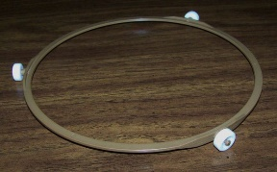  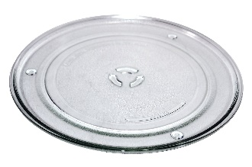
Step 4:  Clean all areas of the microwave including the door and hinges  This makes sure there is no stale food to go mouldy or germs left in the microwave | 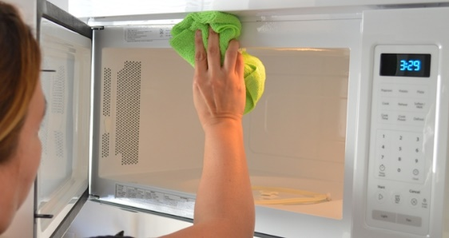
Step 5:

Clean the glass turntable and it’s base

This makes sure there is no stale food to go mouldy or germs left in the microwave
Step 6:  Put any base and turntable back in the microwave when they are clean and dry, making sure they are on the fitting properly – this can be quite awkward to do  This makes sure the microwave is ready to use when you need it | 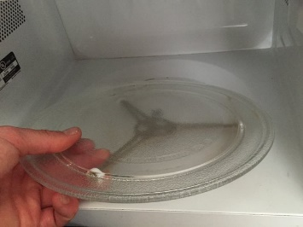
Step 7:  Rinse any sponges or cloths used and pour the water away  This makes sure they are clean for when you need them again | 