Step 1:

If you want to give your oven a thorough clean it is worth remembering that you can pay someone to do it (look online or in yellow pages for companies that do this)

This means you won’t have to use any strong chemicals
Step 2:  Clear everything from the hob and oven including shelves and trays  This will make it easier to clean. | 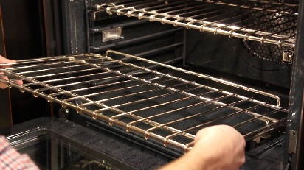
Step 3:  Get a bowl of warm soapy water (or cleaning spray & cloth or cleaning wipes)  Make sure you follow the instructions on the cleaning product for how much to use. | 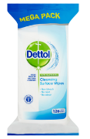  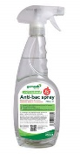  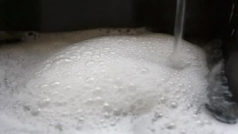
Step 4:  Clean all areas of the oven including the door, hinges and any shelves taken out  This makes sure there is no stale food to go mouldy or germs left in the oven | 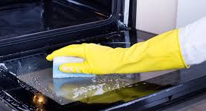
Step 5:  You might need another bowl of clean water now.  Clean all of the hob including any edges  This makes sure there is no stale food to go mouldy or germs left in the oven | 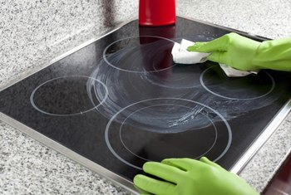
Step 6:  Put any shelves or trays back in the oven when they are clean and dry, making sure they are level  This makes sure the oven is ready to use when you need it | 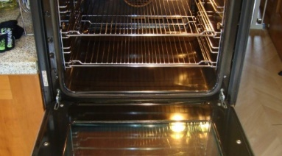
Step 7:  Rinse any sponges or cloths used and pour the water away  This makes sure they are clean for when you need them again | 