Step 1:  Clear the area you want to clean completely – just do one area at a time  This will make it easier to clean. | 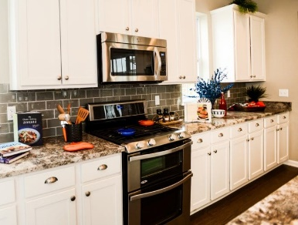
Step 2:  Get a bowl of warm soapy water (or cleaning spray & cloth or cleaning wipes)  Make sure you follow the instructions on the cleaning product for how much to use. | 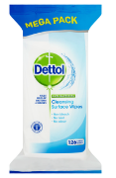  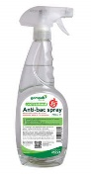  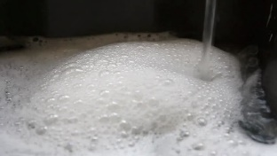
Step 3:  Clean all areas of the work surface including any edges and where it joins the wall  This makes sure there is no stale food to go mouldy or germs left on the surface | 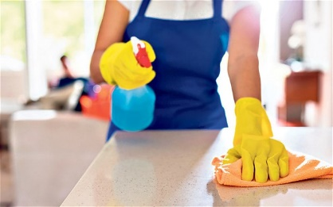  1280 × 720
Step 4:  Make sure the work surface is dry  Make sure you do all edges and where it joins the wall | 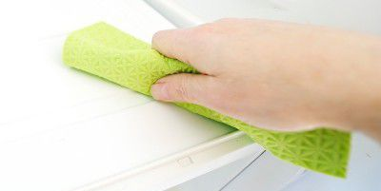
Step 5:  Put everything back tidily and in the right places  This makes sure things are easy to find when you need them | 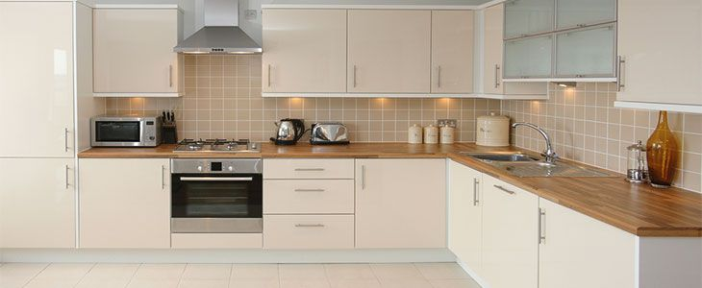
Step 6:  Rinse any sponges or cloths used and pour the water away  This makes sure your cloths are clean for when you need them again | 