Step 1:  Remember to follow the instructions on the product you are using. Furniture polish will also need a duster or microfibre cloth. Microfibre cloths are good to dry an area if you choose to use spray or wipes.  There are lots of different products available and some are used differently | 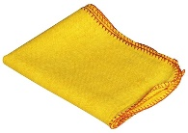  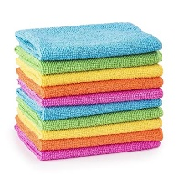  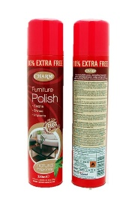
Step 2:  Carefully move anything that is on the area you want to dust out of the way (such as ornaments, photos, paperwork)  This will make it much easier to clean | 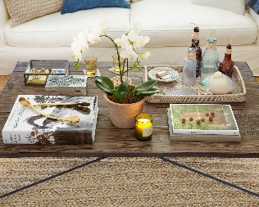
Step3:  Spray the area you are dusting (just do one area at a time) | 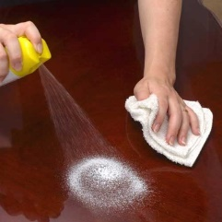
Step 4:  Wipe over with the duster/microfibre cloth until dry | 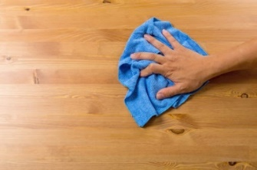
Step 5:  Check there are no streaks or smears as you might have to wipe it over again  If you don’t dry it properly you could damage your furniture | 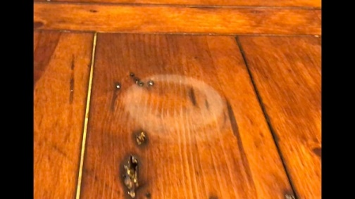
Step 6:  Put everything back where it should be | 
Step 7:  Wash any cloths you have used following the instructions (some can only be washed by hand) | 