Step 1:

Take off all the dirty bed linen and put it in the washing machine or laundry basket and get the clean bed lined ready to put on the bed

Make sure you take off the sheets, covers and pillowcases
Step 2:  Start with the bottom sheet, if it is a fitted sheet, spread it out and fit the corners around the corners of the mattress and tuck in along all edges  If it is a flat sheet do the same but make sure your corners are folded under neatly and tightly | 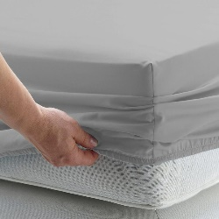  1280 ×
Step 3:  For the top sheet spread the sheet over the bed evenly leaving a small gap at the top of the bed. At the foot of the bed tuck in the sheet tightly and smoothly being careful to fold on the corners so it doesn’t bunch up.  This makes sure the sheet stays in place and there are no extra creases | 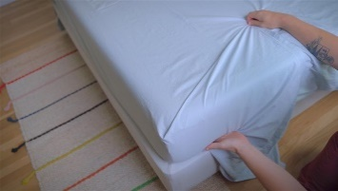
Step 4:

Put the pillowcase on your pillow, tucking the pillow into the ‘envelope fold’ at the end

This makes sure the pillow stays in the cover
Step 5a: There are 2 main ways of putting the cover on a duvet – chose which is best for you between 5a and 5b  Turn the cover inside out, get the top corners of both the cover and the duvet in your hands and then shake the cover down over the quilt while standing up. | 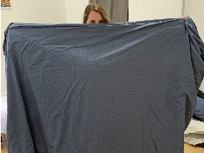
Step 5b:
Some people find it easier to lay the cover on the bed and push the top corners of the quilt in to the corners of the cover and then shake in place.

There is no right or wrong – find the way that easiest for you!
Step 6:  Do up the fastenings at the bottom of the quilt (this can be buttons or press-studs) | 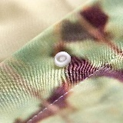
Step 7:

Make the bed tidy by putting the pillows and duvet on neatly

