Step 1:  A weekly meal plan will help to make sure you eat healthily and have to go shopping less often. Get a pen and paper ready  It will also make sure you don’t waste any food and help save money | 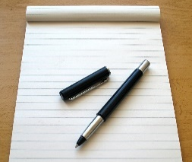
Step 2:

Write down your meal ideas (or ask someone to support you with this). Make sure you include everything for each meal, including salad, vegetables and any other extras like sauces or gravy
You could look in recipe books or on the internet for some ideas too
Step 3:  Think about each meal and write down everything you will need for every meal – you might find you need the same thing more than once (for example you would need mince for both lasagne and Bolognese) | 1280 × 720
Step 4:  Make your long list into a shorter one by adding things together that you need more than once  Sometimes it is cheaper to buy bigger packs as long as you can store them properly when opened | 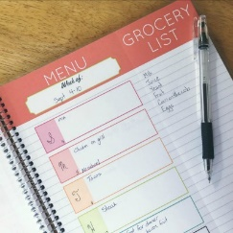
Step 5:  Check the fridge and cupboards to see if you need any daily items such as milk, bread, butter, drinks etc. | 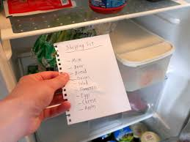
Step 6:

When you have a meal shopping list you will need to think about any other shopping you might need such as drinks, toiletries, toilet rolls and cleaning products

