Step 1:  Empty out the kettle completely  This will makes sure you are not using stale or dirty water. | 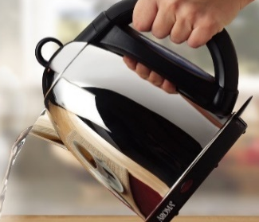
Step 2:  Put water in the kettle – make sure you fill to above the ‘min’ (minimum) line and under the ‘max’ (maximum) line  If it is hard to hold the kettle under the tap use a jug to fill it instead | 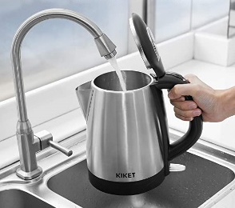
Step 3:  Make sure the kettle is on the base properly.  Turn on at the socket and turn on the kettle | 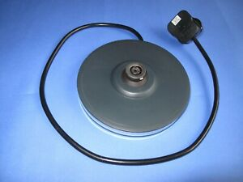
Step 4:  Wait for the kettle to boil  It should turn off automatically | 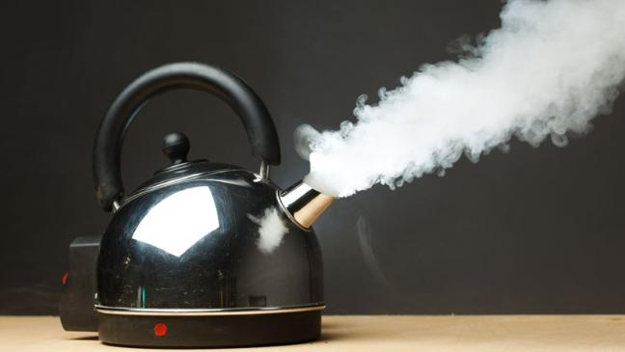
Step 5:  Carefully pour the hot water where you need it  If this is hard you can buy a kettle pourer to help | 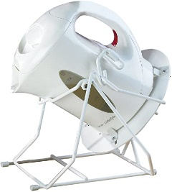
Step 6:  Make sure you put the kettle back safely  Remember it is still hot | 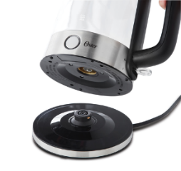
Step 7:  Turn off at the socket | 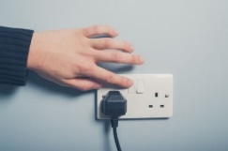
Step 8:  Clean your kettle regularly (when you see a white build-up of limescale) to get rid of limescale  If you buy descaler follow the instructions on the descaler packet. | 