Step 1:  Plug in the toaster and turn on at the wall  Remember to follow the instructions for your toaster as some might be different to others | 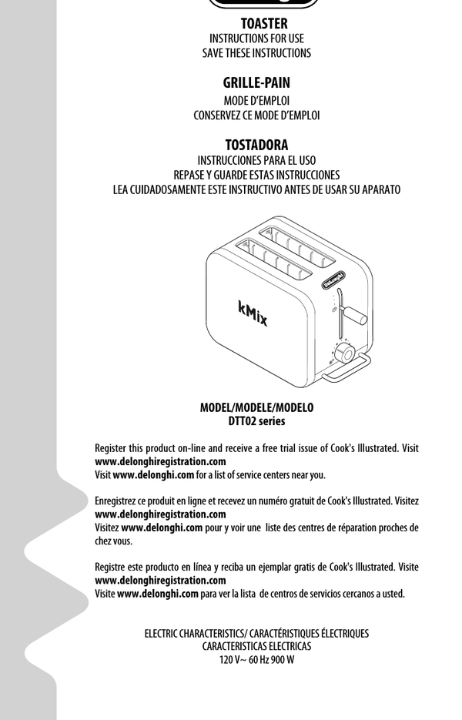
Step2:  Put the bread in the slots. Choose the level of toasting you want.  This is usually a dial with 1 being pale and the higher number for dark toast | 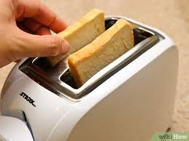  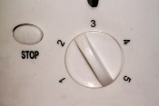
Step 3:  Push the lever down to lower the bread into the slots. | 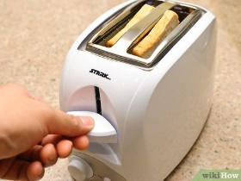
Step 4:  Stay with the toaster. If the toast starts to burn (or is too dark for you you) press the cancel/stop button to make the toast pop up | 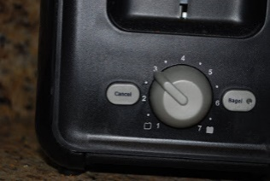
Step 5:  Carefully take the toast out. You can use silicon or bamboo tongues to make this easier. DO NOT USE METAL  If you use metal you could touch the toaster elements which could give you an electric shock needing medical assistance | 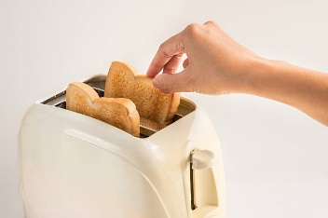  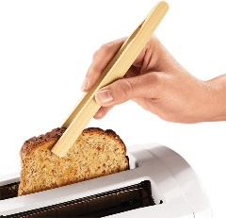
Step 6:  Turn off at the wall. Unplug the toaster  Butter you toast (or add other toppings!) and enjoy | 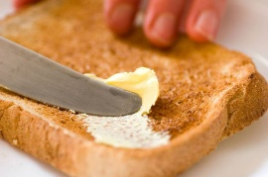  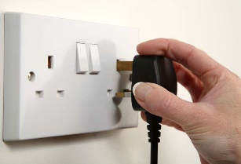
Step 7:  Make sure you keep the area around the toaster clear, including on top, even when cold as it could be a fire hazard.  This is because all of the toaster will get hot | 