Step 1:

It is important to deal with any spills or breakages straight away so that nobody hurts themselves
Step 2:
Clear up as much as possible including any broken pieces using a dustpan and brush and tip into your household rubbish bin straight away

This will stop you cutting yourself when trying to pick it up
Step 3:  Get a bowl of warm soapy water (or cleaning spray & cloth or cleaning wipes)  Make sure you follow the instructions on the cleaning product for how much to use | 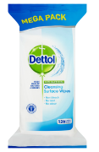  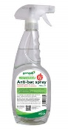  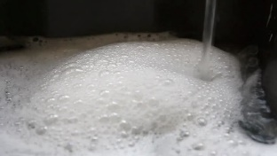  1280 × 720
Step 4:

Clean all areas where the spill/break happened including under any furniture
BE CAREFUL THERE ARE NO BROKEN PIECES OR YOU MIGHT CUT YOURSELF

Step 5:  Make sure where the spill happened is as dry as possible  This makes sure you won’t slip over | 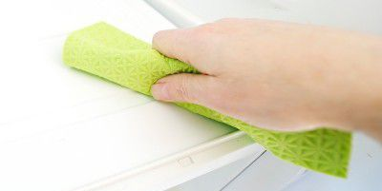
Step 6:  Rinse the dustpan and brush and any sponges or cloths used and pour the water away  Be careful in case there are still any broken pieces anywhere | 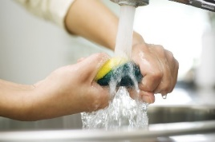
Step 7:  Thoroughly wash your hands | 