**LAZAR NEWS & VIEWS**

Edition 1

November



Contributors and editors:

Rosy, Kyle, Jamie, Danny, David, Harry

Please enjoy the first edition of our Lazar House newsletter. In this edition you can expect: horoscopes, jokes, advice, reviews, sporting predictions, short stories and good news. Something for everyone. If you have something you’d like to see in our newsletter (something to share, a joke you like, a question to ask or anything else) let us know

**Ask a Member**

1. “I am a shy person. How do I make friends at Assist?”

Go to someone and say hello and introduce yourself. Ask people questions about them

1. “What’s the best thing to get for lunch at the Denmark café?”

Sausage and chips. Only £4.80

1. “What should I do to make me feel better if I feel upset?”

Tell someone – talk to a friend or a member of staff

1. “I’ve had an argument with my friend. What should I do?”

Try and solve the problem by talking without shouting. Sort it out.

1. “Recently I have been feeling left out. What should I do?”

Join in or find something else to join in with. Find someone else to talk to.

1. “Changes in my life are making me feel overwhelmed. What can I do to feel calmer?”

Ask for help. Talk about how you feel.

1. “I am struggling with my confidence recently. How can I feel more confident in myself?”

Push yourself out of your comfort zone. Put yourself out there

1. “I’m finding it difficult living independently and doing all the tasks on my own. What should I do?”

Ask your support worker or carer for help

**Harry’s Football Predictions**

Ipswich will stay in the premier league but they need some more wins.

Norwich will get some new players to get promoted.

Leicester might get sent down – it’s very tight.

Liam Delap is going to score more goals for Ipswich. He is a strong player.



**LAZAR NEWS & VIEWS**

**The friendly unicorns – A Short Story**

There once was a unicorn and a girl, they were friends. The girl went to school and the unicorn was lonely at home by itself so it went to the forest to find more unicorns. When the girl came home the unicorn had made lots of friends in the forest. The girl had a brought a friend from school home so the unicorn told the girls about its new friends.

At the weekend they went to the forest together and the girl met all the other unicorns so she now knew all about the forest and the other unicorns. She invited them all to come home with her and the unicorn so then the unicorn was not lonely, it was happy.

The girl still went to school so the unicorns stayed at home and had fun together. The girl’s mum and dad and twin sister and brother loved having unicorns live with them, so the girl and her brother and twin sister all went to school and the girl and her sister thought about how much they loved unicorns. The girl, twin sister and brother went home and played with the unicorns. The mum and dad went to work and came home and made dinner for the girl and her sister and brother. Mum and dad and the unicorns watched TV together and then they all went to bed.

They woke up and it was the weekend so they all went out and went for a walk in the forest, the mum and dad and twin sisters and brother and unicorns. When they went home they went to bed, they were tired.

Then they woke up to Monday morning and the sisters and brother went to school and the mum and dad went to work. The unicorns stayed at home and had fun. The sister brought a friend home with her after school so the sisters and their friend all played with the unicorns, and the brother played too. The mum and dad came home after work and they were bored so they played with the unicorns too. Then they all went to bed.

The mum and dad and brother and the twin sisters and their friend and the brother all woke up. The twin sisters and their friend and the brother went to school together, and the mum and dad went to work and the unicorns all stayed at home and had fun together.

**Dog rescued after it was seen floating down canal on shopping cart and gets adopted into a loving home**

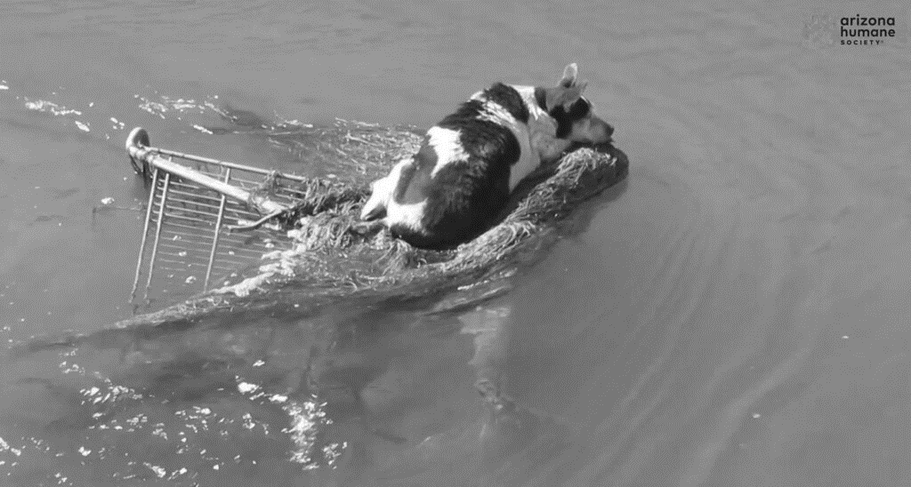

**Harry’s Review of the Giggling Squid**

I recently visited the Giggling Squid for my birthday, which is a Thai restaurant. I ate the spicy sharing platter, which had some marinated skewers. I also shared some other platters which was the Fisherman’s Feast and Bangkok Bites. ! My favourite was the prawn skewer. I had a beer to drink, which was very tasty and went well with my meal. The decoration in the restaurant is lovely, and the layout is very pretty, especially the stairs. I also found the seats very comfortable. The servers were very friendly, and said hello to mum, dad and I. I would give the Giggling Squid 5 stars and 10/10!

**LAZAR NEWS & VIEWS**



Sagittarius

Nov. 22-Dec. 21

It’s totally understandable if you are feeling off your centre and not sure which of your impulses to trust. This week it’s wise for you to slow down and tap in. Reconnect with your values as a way to both remind yourself of where your attention and energy are most needed, but also to help you identify what stage of development you’re at and what needs your attention in the here and now. Stay present, Sagittarius.

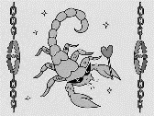

Scorpio

Oct. 23-Nov. 21

This isn’t the time to wallow in anxiety or wring your hands over upsets. With the November 15th full moon in your relationship house, it’s wise for you to make choices that you can act on in the short term, Scorpio. You don’t have to do everything all at once, but it is wise for you to start the ball rolling in a direction that you feel good about. If change is inevitable, how do you want to create the conditions for your best evolution?

# Zodiac

# Weekly Horoscopes

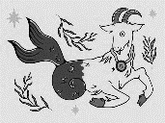

Aries

Mar. 21-Apr. 19

A week after the Sun left your financial sector, the Moon is not only here but with a chance to both regroup and pivot. Coming full circle from last month's New Moon and from the most active months of the year on this side of the financial fence, now that your annual financial housekeeping is over, an alignment with the asteroid Juno, the queen of commitment is a chance to focus more on your financial resolutions moving forward. While the income side of the financial fence will remain active, when it comes to money matters it is now more about having something you can commit to.

Capricorn

Dec. 22-Jan. 19

If you waste your time trying to figure out whose fault it is, you’re not tending to the things that would be most productive for you to focus on. This week it’s wise for you to tend to your emotions, especially if you’ve been feeling bogged down. The best way for you to access your creativity and to identify the best options in front of you is by first coping with your emotional landscape. All you need to do is your part, Capricorn.

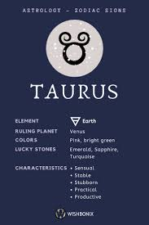

Taurus

Apr. 21- May.21

On the one hand, there is nothing different about the friendly aspect between the Moon and Saturn that makes this a good day for friendship and relationship building. After all, since his return to your relationship sector in March 2023, the Moon's monthly visit to your friendship sector will always put them at a friendly aspect. The difference today is that this first visit since Saturn turned direct also has the Moon aligned with the asteroid Juno, the queen of commitment and especially commitment to your relationships. This is putting a lot more focus on the future while fostering a sense of commitment.

**LAZAR NEWS & VIEWS**



**Hillside Animal Sanctuary, as told by David**

Hillside Animal Sanctuary was founded in 1995 to help animals in need. They have helped 2500 horses, ponies and donkeys over the years.

David: ‘I love it at Hillside. They have horses in the stables where I can feed them and make a fuss. There are 5 Suffolk Punches, and my favourite is the big horse! He is as soft as anything, a real big softie. He puts his head on my shoulder, and is a real lovely horse. They also have some pot belly pigs, and they are ever so friendly! There’s more where that came from… there is also sheep, rabbits, llamas and goats. The goat has watched me eat my lunch before, and even sat in my lap! The sanctuary has a shop, where you can buy a large range of items such as calendars, t-shirts and diaries and all profits go towards the farm. There is also a lovely café, where they had lots of options such as vegan food. I frequently visit the sanctuary, and I can’t wait to visit them for Christmas to see their decorations.

**Britain Celebrates Birth of Baby Bongo Antelope – With Fewer Than 100 Left on Earth**

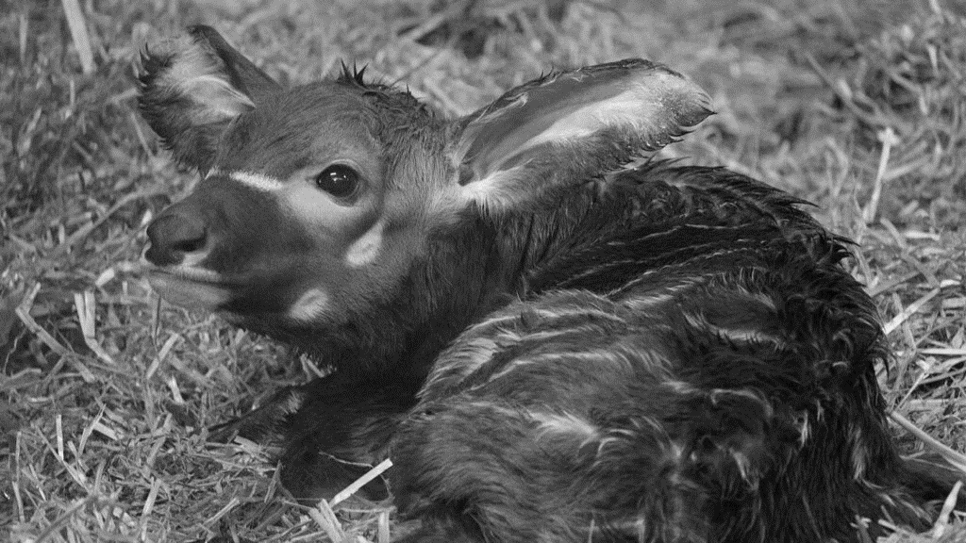

**The Jokes**

Why were the teacher’s eyes crossed?

She couldn’t control her pupils.

What starts with E, ends with E, and has only 1 letter in it?

An Envelope.

How does the ocean say hello?

It waves.

Why shouldn’t you write with a broken pencil?

Because it’s pointless.

Why are teddy bears never hungry?

Because they’re always stuffed

Where do cows go for entertainment?

The mooooo-vies!

How does NASA organize a party?

They planet.

Why did Adele cross the road?  To sing, “Hello from the other side!”