**LAZAR NEWS & VIEWS**

Edition 4

February



Editors and contributors: Kyle, Danny, Jethro, Rosy, Jess, David, Jamie, Harry

Welcome to the 4th and final edition of our newsletter. We have had a great time writing this one and we hope you enjoy it. At the end of this edition, you can find our playlist – perfect for enjoying while you read this newsletter. Thanks for reading ☺

On the buses

Buses with no number are called city clippers, buses with a number are called just Clippers. I have been on an open top bus. The bus travelled from Great Yarmouth to Hemsby and was a clipper bus. When you go and sit on it there is someone telling you about different thing in Norwich. That one’s a city clipper

By Harry



Everything you ever wanted to know about foxes

Foxes are omnivores and this allows them to survive in a wide range of habitats. Rabbits and voles are a common prey, but a fox’s diet can include everything from worms and beetles to deer and fruits like berries. Female red foxes give birth to a litter of cubs in a underground den. They have around four or five cubs that will be cared for by both the male and female red foxes. Red foxes have a reddish- brown coat with a white bib, black ears and a bushy tail. Adults weigh around 4.5kg and 10kg and their average length is between 45cm and 90cm excluding the tail. A red foxes live in woodlands and farmlands. Red foxes can live for 9- 10 years. Red foxes are known for their wide range of vocals including barks, screams, whines and howls. They can jump over 2 meters high that’s allows them to easily jump over fences to explore new territories to search for food.

By Jess

A fox and a deer having a fight with little girl watching

By Danny

**LAZAR NEWS & VIEWS**

**LAZA LAZAR NEWS & LAZAR NEWS & VIEWS**

**NEWS & VIEWS**

**R NEWS & VIEWS**

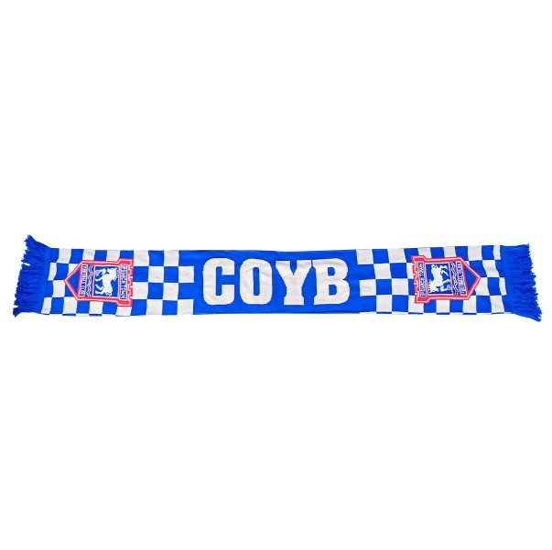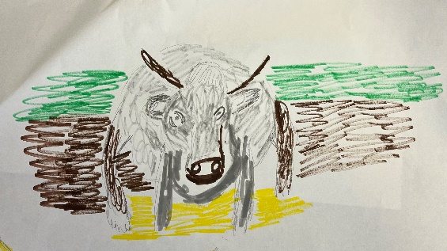

I like the faces of the cows. They look sweet. The cows have very long horns. The cows can be white with brown patches or white with black patches. They lay down in the fields.

By David

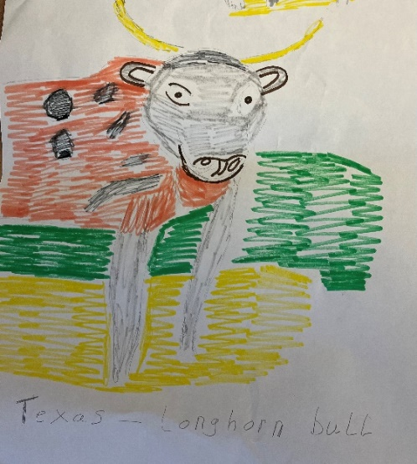

My trip to Ipswich

My step dad took me to Ipswich. Before the game started we had a McDonalds for lunch. The fans made a great noise. I thought it would be 2-1 but it was 6-0! After, me and my step dad had spicy sausage pasta. It was nice.

By Harry

**What you need to be a DJ**

A DJ is an art form itself. It takes practice it takes a couple of days to learn the effects and soft where and you need this equipment.

By Kyle



I like watching classic doctors. I think it is really good. I watch it every day and every evening it. There are some good characters and some naughty ones. I have enjoyed watching it for a few months. There is an app called U which can be loaded on to a phone or tablet so episodes of Doctors can be watched where ever I go. Series 5 is what I am watching currently. Some of the episodes are sad because bad things happen but they are all good. I would recommend them to anybody to watch. It is my 10 out of 10 T.V programme. If you like programmes such as Holby City or Casualty you will probably like the programme Doctors.

By Rosy



DELIA SMITH

My favourite tv cook is Delia Smith because she use to do all the recipes on television and she used to do cooking on the tv programmes. She used to do complete cookery course, one, is fun, summer collection, winter collection how to cook part one, part two, part three, how to cheat and vegetarian cooking and Christmas. She was also a Norwich City football and her husband was a keen cricketer and she use to do afternoon tea and food at the cricket ground where he plays cricket

**LAZAR NEWS & VIEWS**

**LAZA LAZAR NEWS & LAZAR NEWS & VIEWS**

**NEWS & VIEWS**

**R NEWS & VIEWS**

Type 1 diabetes

Type 1 diabetes is a condition where the immune system mistakenly attacks the beta cells in the Pancreas that creates insulin and destroys them when enough are destroyed the Pancreas can’t make insulin.

Type 1 diabetes is managed by injecting insulin or a insulin pump too much insulin causes low blood sugar. If type 1 diabetes isn't treated probably it can lead to serious health problems. The symptoms of type 1 diabetes are excessive hunger, excessive thirst blurred vision, fatigue, and seeing a lot.

An insulin pump is a small device which is attached to the skin and wear all the time, it gives tiny amounts of insulin throughout the day and night.

Without insulin blood sugar can't get into the cells and builds up in the bloodstream. High blood sugar is damaging to the body and causes the symptoms of diabetes

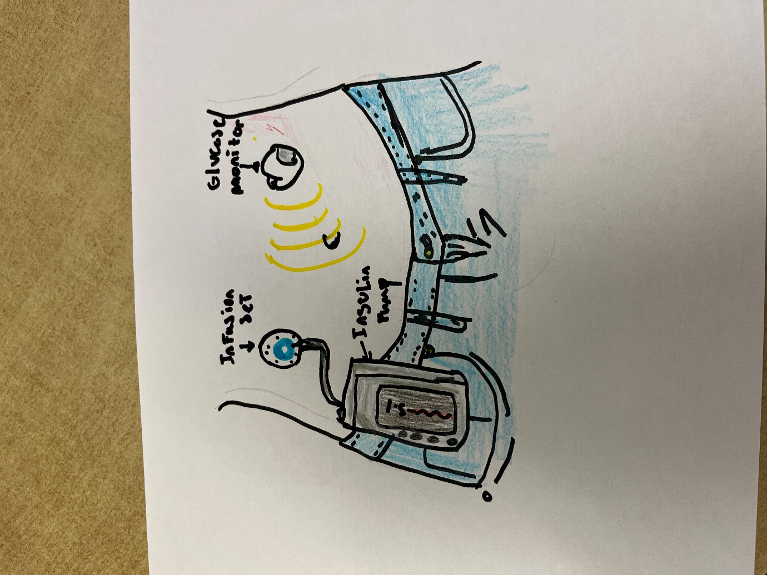

TRIP TO DENTIST

On Wednesday Mum came to take me to the dentist. When I arrived I went into the room where they checked my teeth then I met Harry who was going in to have his teeth checked then I came back home.

By Jamie

Birthday party

I went to a friend’s birthday party. We went bowling to play two games. I won both games. We went to Namco and then cow tower. There is a big clock with lamps. It was brilliant

By Harry

My favourite Bonds

Roger moore is in Live and let die, The Man with the golden gun, the spy who loved me, Moonraker, for your eyes only, Octerpussy and A view to a kill

Sean Connery is in Dr.no, from Russia with love, Gold finger, thunder ball, You only live twice and Diamonds are forever

By Jamie



By Jess

**LAZAR NEWS & VIEWS**

**LAZA LAZAR NEWS & LAZAR NEWS & VIEWS**

**NEWS & VIEWS**

**R NEWS & VIEWS**

Messi and the MLS

Lionel Andrés "Leo" Messi is an Argentine professional footballer who plays as a forward for and captains both Major League Soccer club Inter Miami and the Argentina national team. Widely regarded as one of the greatest players of all time, Messi set numerous records for individual accolades won throughout his professional footballing career such as eight Ballon d'Or awards and eight times being named the world's best player by FIFA. He is the most decorated player in the history of professional football having won 45 team trophies, including twelve Big Five league titles, four UEFA Champions Leagues, two Copa Américas, and one FIFA World Cup.

He’s the first footballer to make the sport huge in America



By Kyle

After his beloved yoga ball deflates, downhearted donkey now has donated balls from Canadians.

By David

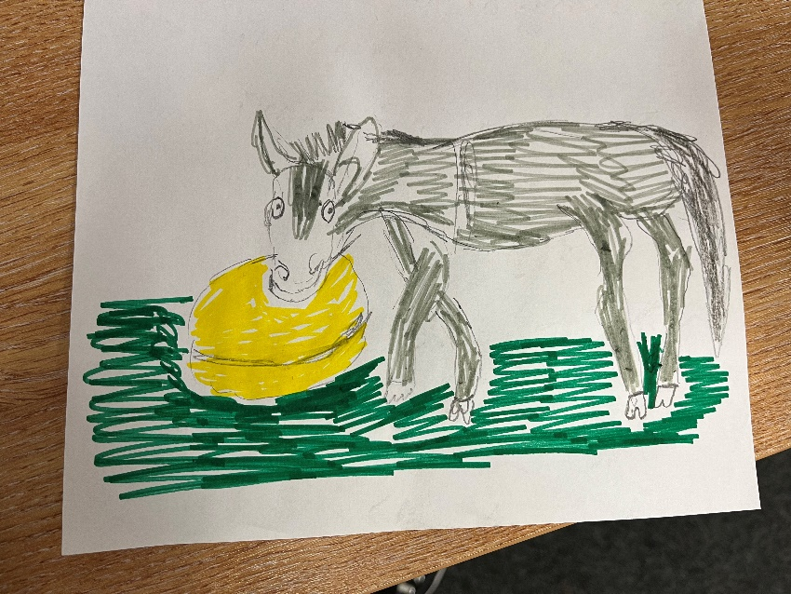

Ask a member

What is a group you’ve enjoyed doing here at Assist?

Dancing

Cooking

Sew creative

Gardening

Café

Sports

Art attack

Drama

Swimming

Gym

Newsletter

Zumba

By David & Jess

TELEVISION PROGRAMMES I LIKE

My television programme that I like is called Last of the Summer Wine I watched it last night because one of the chaps Bill Owen who played Compo died and it was sad. His son Tom played by Tom Owen met the others at the feathers pub. The last of the summer wine was set in a town called Homfirth south of Huddersfield in West Yorkshire

By Jamie

TRIP TO MINITURE RAILWAY CENTURE AT WROXHAM

On Tuesday one of the staff and Emma to us to the railway centre to look at the train sets. There were about 8 train sets in the building. We went around the trains and we watched the trains passing us it was quite fun because I like trains and I have been on a steam train and an electric train

By Jamie

**LAZAR NEWS & VIEWS**

**LAZA LAZAR NEWS & LAZAR NEWS & VIEWS**

**NEWS & VIEWS**

**R NEWS & VIEWS**



Waterloo Road is a good program. It is about a school and was on tv and then it finished and then they brought it back. Some of the episodes are sad but I like them all. They have good characters and bad characters. Some of the students from the old show are now grown up and their children go to the school and one of the old teachers is the head teacher now.

One of the teachers on one of the old episodes takes one of the girls and adopts her because her mum boyfriend was abusing the girl form the school and her mother took the boyfriend’s side so she could not stay with her mum anymore. Then a new family came and starting going to the school and one of the boys from the new family had a knife and the girl started to go out with the naughty boy who had the knife. She dumped him, he did not like that so he hurt her. One of the girls from the old episodes had a daughter with her boyfriend. She now has a son too. Her daughter goes to the school new but the mother was knocked down by a car and died, so the boyfriend (who is now the husband) has to bring up the children by himself and he is not very good at it. He becomes the caretaker of the school and he starts going out with the dinner lady but the daughter of the dinner lady and the caretaker’s daughter were fighting so they fell out. The two daughters do not like the fact their mum and dad are going out and then the dinner lady gets kicked out of her house and moves in with her sister and mum but her sister is not happy about it and the dinner lady tells her she is not looking after her daughter and giving her daughter the wrong drugs.

I really like this program and I would recommend it to anyone to watch. If you are having a bad day then it will take your mind off it and cheer you up. It is my second 10 out of 10 program. I think you should watch it. I am go to watch it when I have finished watching things on U. I have watched some of the series before. I think you would probably like it if you used to like Grange Hill and Biker Grove and if you like Ackley Bridge.

By Rosy

Newsletter playlist

Nicki Minaj Super Freaky Girl

David Guetta & Bebe Rexha I’m good

Bob Dylan Mr. Tambourine Man

Ed Sheeran Bad Habits

SUICIDAL-IDOL - ecstacy

ROSÉ & Bruno Mars APT.

SIX The Musical

Vengaboys Boom, Boom, Boom, Boom

Depeche Mode Just Can't Get Enough

Jack Harlow Lovin On Me

Johnny Nash I Can See Clearly Now

By Rosy, Kyle, Jess & Harry

Say Cheese!

We will be having a professional photographer coming to see us and take some pictures on 6th March at Colegate and 7th March at Lazar. Remember to wear something nice and practice your best smile!

p

THANK YOU FOR READING